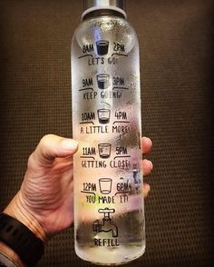

**We need regular intake of fluids throughout the day to stay healthy; this is especially true for growing children. Fluids lost throughout the day from sweating, breathing, and urinating need to be replenished.**

* Be a ***good example*** and model yourself – build healthy habits together
* Keep water ***on hand*** and ***offer frequently*** especially in the Spring and Summer months
* Add fruit for ***fun flavor*** (lemons, oranges, berries)
* Increase intake of ***fruits and vegetables***
* **Monitor the color of urine**
  + Urine with a slight hint of color means healthy hydration
  + Urine that is yellow indicates that you need more fluids
  + Urine that is dark yellow or brown indicates that you need to drink quite a lot
* Some ***signs and symptoms*** of dehydration are headache, nausea, fatigue, and dizziness.
* <https://www.chop.edu/news/health-tip/how-keep-kids-hydrated>
* ***Water*** is the **BEST**
* ***Unflavored milk*** is also **GOOD**
  + whole milk for toddlers and skim or 1% for kids older than 2 years old
  + has the additional benefit of calcium for growing bones
* ***Sports Drinks*** and ***juices*** are **NOT GOOD**
  + they are loaded with sugar and don’t help when thirsty
  + increase the risk of obesity
* ***Soda*** is the **WORST**
  + please avoid or only have on a special occasion for a treat

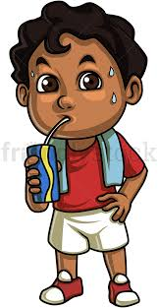

**The Challenge is on………..**

**Send me pictures of you drinking water in your most creative and fun way and I will pick a winner at the end of the week and send you a special prize!!!!!! Send to** [**cslavin@philasd.org**](mailto:cslavin@philasd.org)

**As always, please consult your health care provider for any questions or concerns**